Kazakh-British Technical University
Data collection and preparation

STUDENTS' INDEPENDENT STUDY (SIS) №1
«Credit Affordability & Interest Rate Trends in Kazakhstan»

Full Name:
Kazybek Aisha
Aigerim Zhumzhumina
Karas Yerassyl
Uteuliyeva Gauhar
ID:
23B031323
23B031309
23B031334
24B032089

07.10.2026
Almaty

1. Introduction
This project examines how affordable consumer credit is in Kazakhstan. Two questions guide the analysis:
- How have rates on loans to individuals behaved over the long run relative to inflation and other macroeconomic indicators (2005–2026)?
- Today, how expensive are consumer loans at individual banks compared with inflation, the National Bank of Kazakhstan (NBK) base rate and the NBK loan-rate reference?
The project covers the full data pipeline: collecting data from three different sources (an API, a web page and an Excel file), cleaning and merging it, and analysing and visualising the result in Python.

2. Data Sources and Collection
Source | Method | Content | Coverage
World Bank WDI via DBnomics | REST API (requests, JSON) | Inflation (CPI, %), GDP per capita (USD), unemployment (%) for Kazakhstan | 2005–2023, annual, 19 observations per indicator
bankchart.kz | Web scraping (requests, BeautifulSoup) | Consumer cash-loan ratings: effective and nominal rates by bank | 11 banks, rating dated 31.07.2026
National Bank of Kazakhstan | Excel file (pandas.read_excel) | Monthly NBK weighted average rate on loans to individuals, including individual entrepreneurs, in national currency (KZT), % | January 2005 – August 2026
Two values were entered manually as current reference points: inflation of 9.8% (August 2026) and the NBK base rate of 16.25% (as of 07.09.2026).
Ethical scraping. Before scraping bankchart.kz, the script downloaded robots.txt and checked it with RobotFileParser. The check confirmed that scraping the ratings page is allowed. The scraper also identifies itself with a descriptive User-Agent and uses timeouts and status checks (raise_for_status).

3. Data Preparation
World Bank data. The three indicators were reshaped from long to wide format (one row per year). All columns were converted to numeric types. The check found no missing values and no duplicated years in the 2005–2023 range.
Bank data. Each bank's block of text was parsed with regular expressions to extract the effective rate ("real rate") and the nominal rate. Decimal commas were converted to points, and values were checked to lie between 0 and 100. The bank name "Bank RBK" was standardised. A derived variable, commission_effect (effective minus nominal rate), measures the extra cost added by fees and commissions. After cleaning there were no missing values or duplicates among the 11 banks.
NBK data. The notebook loads the supplied workbook from the project folder and checks the file, sheet and indicator row. Month labels and rates are converted to appropriate types. It checks missing values, exact duplicates, conflicting monthly rates and gaps in the monthly calendar. The prepared series contains 260 consecutive months (January 2005–August 2026). Annual figures are simple means of monthly rates, with month counts and a full-year flag; 2026 covers January–August only (8 months).
Merging. The annual NBK rates were outer-joined to the World Bank table by year, giving a 22-row yearly dataset (2005–2026). A new variable, rate_minus_inflation, is the average loan rate minus inflation, a simple proxy for the real cost of credit. The bank table was enriched with three spreads: effective rate minus inflation, minus the base rate and minus the NBK monthly weighted average rate on loans to individuals, used as a reference for a different loan-rate measure.

4. Results

4.1 Long-run trends (2005–2026)
The annual mean NBK rate on loans to individuals was relatively stable compared with inflation.
Indicator | Mean | Min | Max
NBK loan rate (%) | 19.25 | 17.09 | 21.99
Inflation (%) | 8.94 | 5.20 | 17.14
Rate minus inflation (p.p.) | 10.04 | 2.26 | 15.73
Unemployment (%) | 5.67 | 4.80 | 8.13
The annual mean loan rate stays within a band of about 17–22%, while inflation swings between roughly 5% and 17%. The most recent annual averages show a gradual increase: 17.29% in 2022, 19.23% in 2023, 19.93% in 2024, 21.06% in 2025 and 21.99% for January–August 2026.
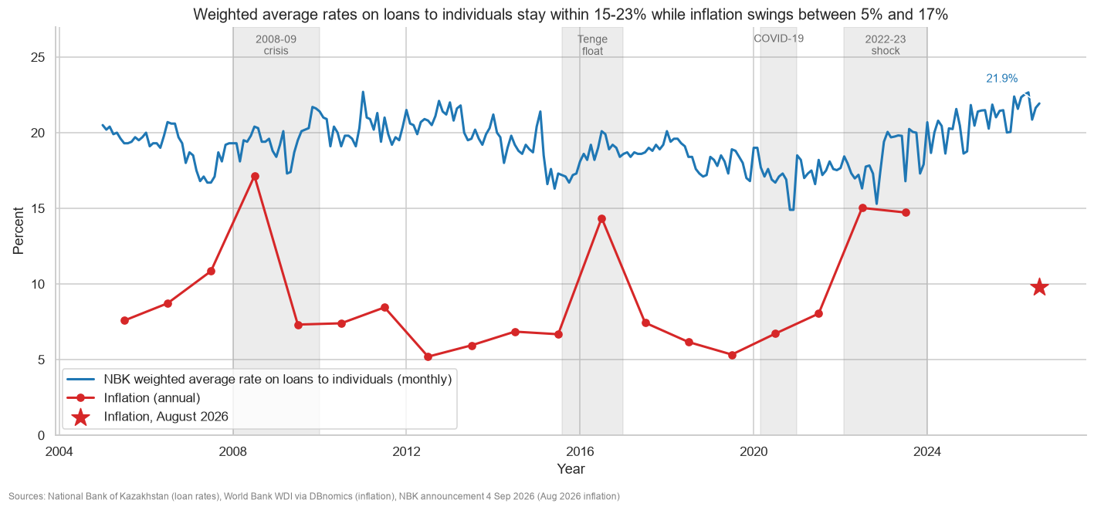
Figure 1. Monthly NBK weighted average rates on loans to individuals and annual inflation; grey bands mark the 2008-09 crisis, the 2015-16 tenge float, COVID-19 and the 2022-23 shock.
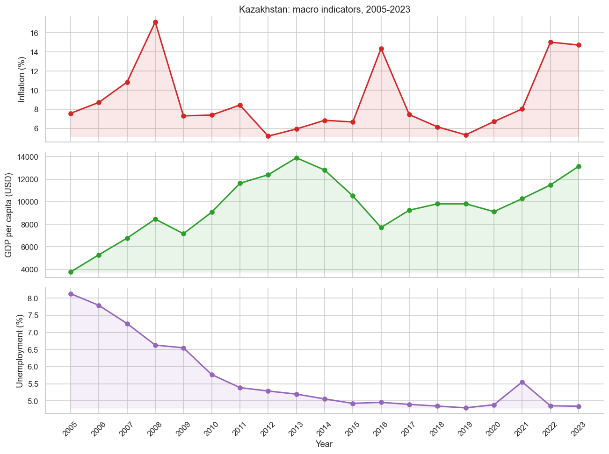
Figure 2. Kazakhstan: inflation, GDP per capita and unemployment, 2005-2023 (World Bank WDI via DBnomics).

4.2 Real cost of credit
Borrowers were not equally burdened across years.
Highest real cost (rate − inflation) | p.p. | Lowest real cost | p.p.
2012 | 15.73 | 2022 | 2.26
2013 | 14.44 | 2008 | 2.30
2019 | 12.69 | 2023 | 4.51
2010 | 12.64 | 2016 | 4.54
2018 | 12.43 | 2007 | 7.02
The rate–inflation gap was highest in calm, low-inflation years (2012–2013, 2018–2019) and lowest in years of inflation shocks: the 2008 crisis, the 2015–2016 tenge float and the 2022–2023 shock. Across the 19 years with both annual series (2005–2023), the NBK loan rate was above inflation. The January–August 2026 mean (21.99%) exceeds August inflation (9.8%) by about 12.2 p.p.
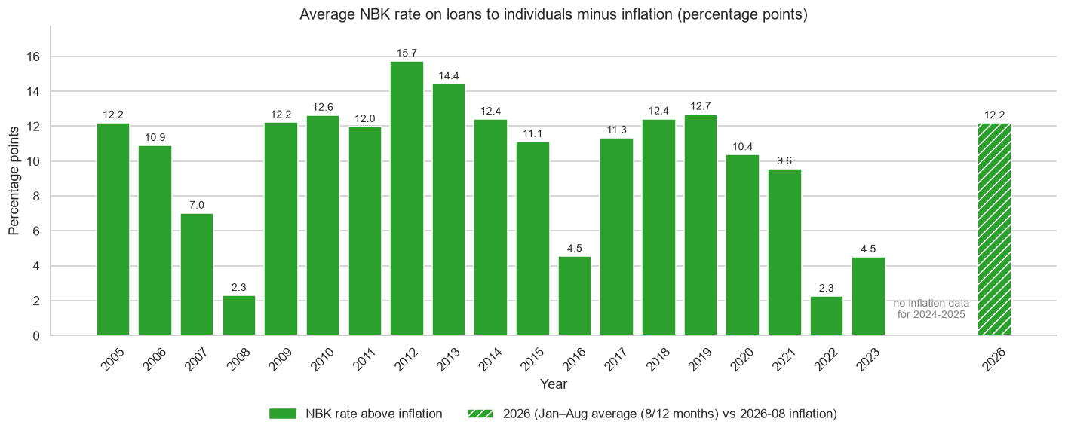
Figure 3. Mean monthly NBK rate on loans to individuals minus annual inflation (percentage points). The 2026 bar compares the January–August mean (8 months) with August inflation.

4.3 Correlations
 | Inflation | GDP per capita | Unemployment | Loan rate
Inflation | 1.00 | −0.07 | 0.09 | −0.15
GDP per capita | −0.07 | 1.00 | −0.78 | 0.09
Unemployment | 0.09 | −0.78 | 1.00 | 0.26
Loan rate | −0.15 | 0.09 | 0.26 | 1.00
The annual NBK loan-rate series has a weak, slightly negative correlation with annual inflation over 2005–2023 (r = −0.15, n = 19). The strongest correlation in the table is between GDP per capita and unemployment (r = −0.78). Correlations involving the NBK loan rate are weak in this sample.
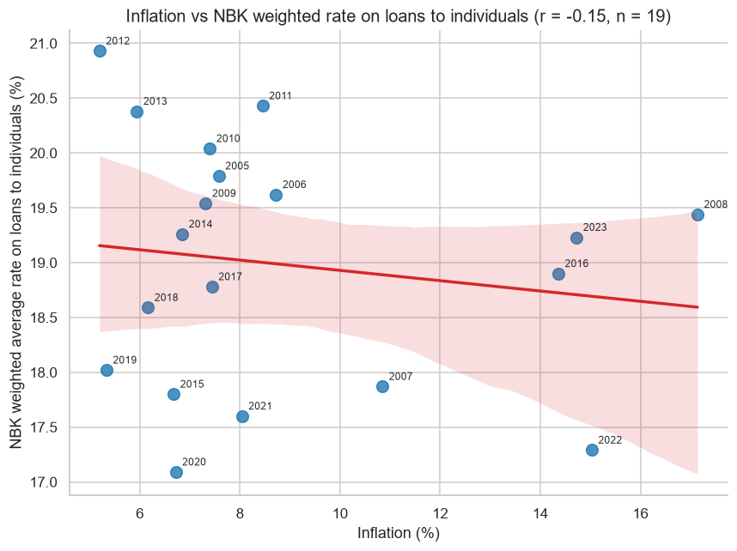
Figure 4. Inflation vs the NBK average rate on loans to individuals (r = -0.15, n = 19): the fitted line is nearly flat.
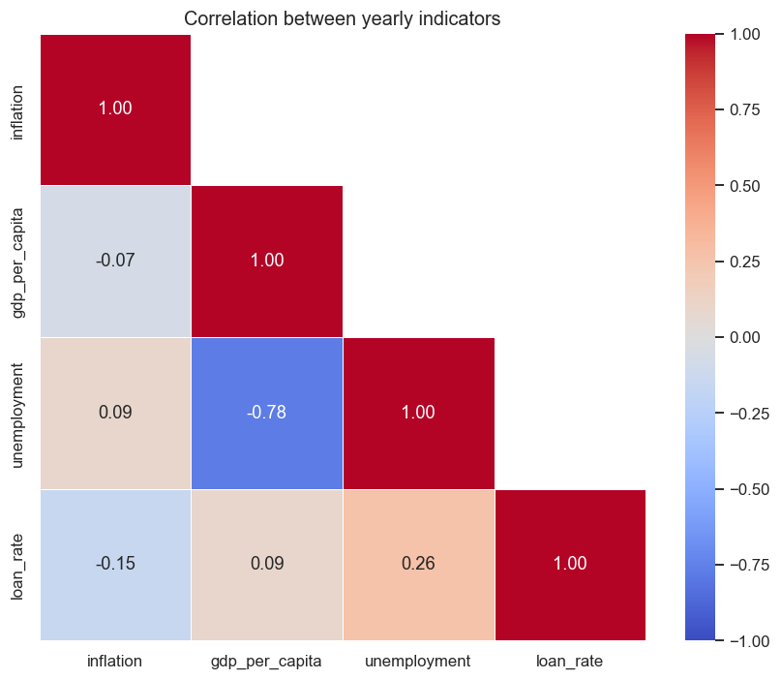
Figure 5. Correlation heatmap of the yearly indicators.

4.4 Bank-level comparison (rating of 31.07.2026)
Bank | Nominal rate (%) | Effective rate (%) | Commission effect (p.p.)
Home Credit Bank | 19.0 | 19.00 | 0.00
Freedom Bank | 20.0 | 20.00 | 0.00
VTB Bank | 20.0 | 20.00 | 0.00
Centercredit Bank | 13.0 | 22.05 | 9.05
Bank RBK | 11.0 | 23.71 | 12.71
Halyk Bank | 17.5 | 24.69 | 7.19
Bereke Bank | 28.0 | 28.00 | 0.00
ForteBank | 28.0 | 28.00 | 0.00
Altyn Bank | 22.0 | 29.15 | 7.15
Eurasian Bank | 30.0 | 30.00 | 0.00
Alatau City Bank | 37.0 | 37.00 | 0.00
Key figures:
- Effective rates range from 19.0% to 37.0%, with a median of 24.7% and a mean of 25.6%.
- The cheapest banks are Home Credit Bank (19.0%), Freedom Bank and VTB (20.0% each). The most expensive are Alatau City Bank (37.0%), Eurasian Bank (30.0%) and Altyn Bank (29.15%).
- The mean effective rate exceeds inflation (9.8%) by 15.8 p.p., the NBK base rate (16.25%) by 9.4 p.p. and the NBK reference (21.93%) by 3.7 p.p.
- 8 of the 11 rates are above the NBK reference; Home Credit, Freedom and VTB are below it.
- No bank offers an effective rate below the base rate; the closest is Home Credit, 2.75 p.p. above it.
- Commissions add 3.3 p.p. on average. Four banks add more than 5 p.p.: Bank RBK (+12.71), Centercredit (+9.05), Halyk (+7.19) and Altyn (+7.15).
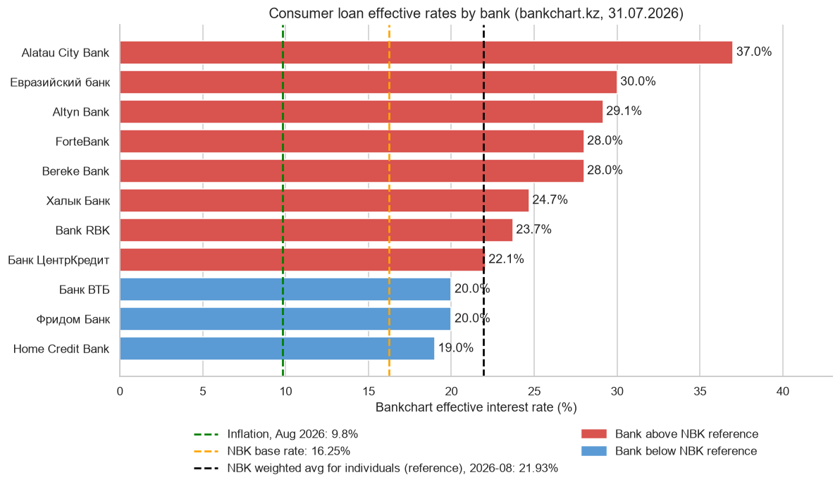
Figure 6. Bankchart effective rates (31.07.2026) with inflation, the NBK base rate and the NBK loan-rate reference; red bars exceed the NBK reference.
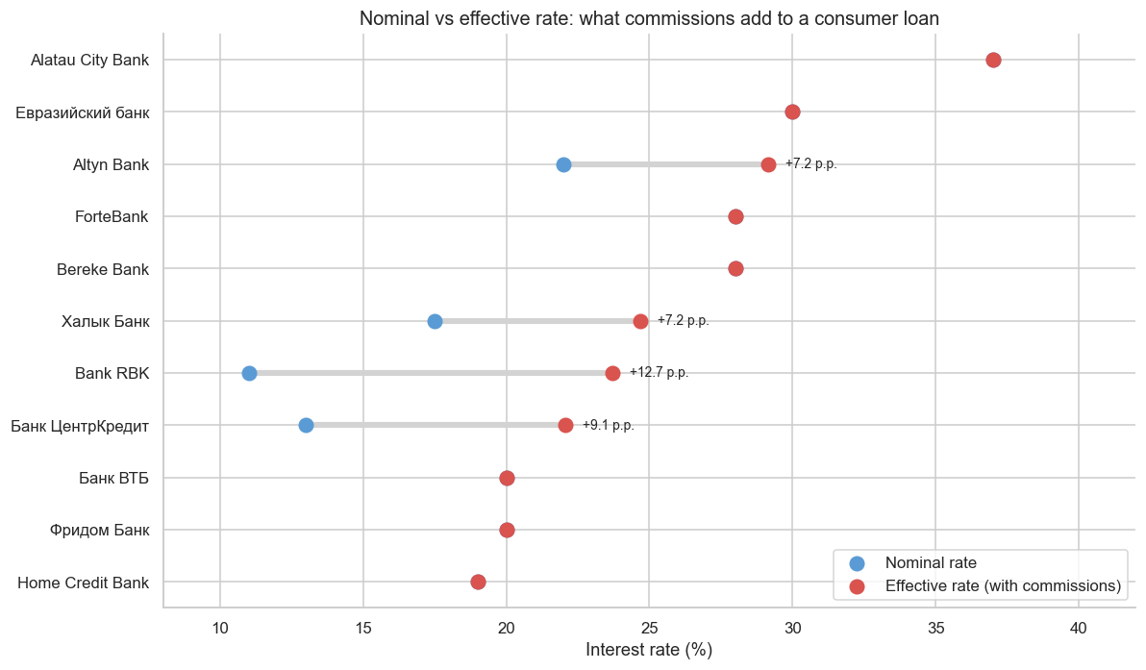
Figure 7. Nominal vs effective rate: what commissions add to a consumer loan.

5. Conclusions
- Loan rates exceed inflation. For the 19 years shared by the annual NBK and World Bank series (2005–2023), the average rate–inflation gap is about 10 p.p. The January–August 2026 mean (about 22%) is the highest among the annual summaries shown, but covers only 8 months.
- Loan rates are sticky. The annual NBK means move within a narrow band and show a weak correlation with inflation (r = −0.15) and the other macro indicators in this sample. Short periods of low real cost, such as 2008, 2016 and 2022–2023, occurred because inflation jumped while loan rates did not follow.
- The advertised rate is misleading. For four of 11 banks, fees and commissions add 7–13 p.p. to the nominal rate. Bank RBK advertises 11% but its effective rate is 23.71%. Borrowers should compare effective rates, not nominal ones.
- Bank choice matters a lot. The gap between the cheapest and the most expensive bank is 18 p.p. on the same type of loan, larger than the whole historical range of the average loan rate.
- Practical implication. With inflation at 9.8% and the base rate at 16.25%, households face real borrowing costs of roughly 9–27 p.p. depending on the bank, so credit affordability depends mainly on comparing offers.

6. Limitations

Period of macro data:

World Bank annual indicators cover 2005–2023. Missing values for later years are not filled; the August 2026 inflation reference is entered separately.

Aggregation level:

The historical NBK series covers loans to individuals, including individual entrepreneurs, in KZT; the bank comparison covers consumer cash loans. Annual NBK figures are means of monthly rates, and 2026 covers only eight months. The reference indicators and the Bankchart rating have different dates.

Nature of the correlations:

Correlations based on 19 annual observations show how the indicators move together, but they do not prove causality by themselves.

Snapshot of banks:

The comparison reflects 11 banks as of 07/31/2026 according to the standard rating scenario, and the actual offers for a particular borrower may vary.

Data collection method:

The bids are extracted for the current page layout, and the same approach can be applied to future ratings.

7. Tools and Reproducibility
Python with requests, pandas, numpy, matplotlib, seaborn, beautifulsoup4 and Jupyter (see requirements.txt). The notebook produces seven figures: loan rate vs inflation over time with crisis periods marked, rate minus inflation by year, effective rate by bank against the three benchmarks, nominal vs effective rate by bank, an inflation vs loan rate scatter plot, macro indicator trends, and a correlation heatmap.

8. Data Sources
- World Bank, World Development Indicators, via DBnomics (api.db.nomics.world)
- bankchart.kz, consumer loan ratings (accessed under its robots.txt rules)
- National Bank of Kazakhstan, interest rates on loans issued by second-tier banks (Excel file)

